

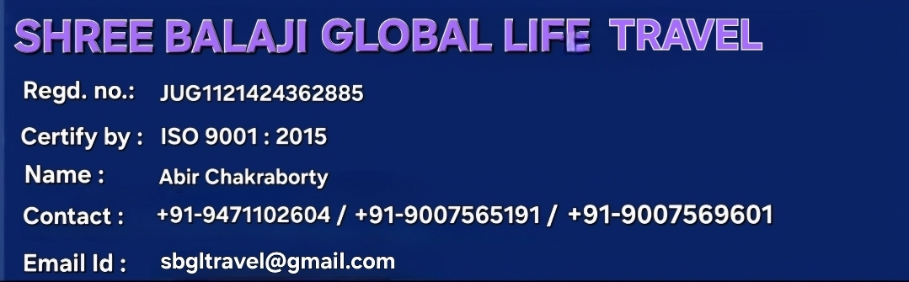

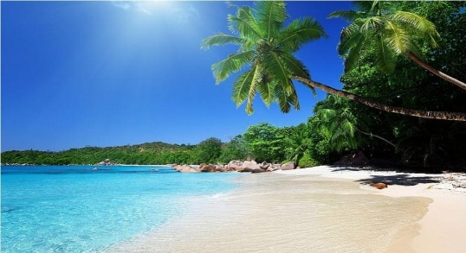
Thailand Tour Packages
TataNagar to TataNagar (8 Days) Tour Plan
Day Wise Itinerary:

Stay
Phuket
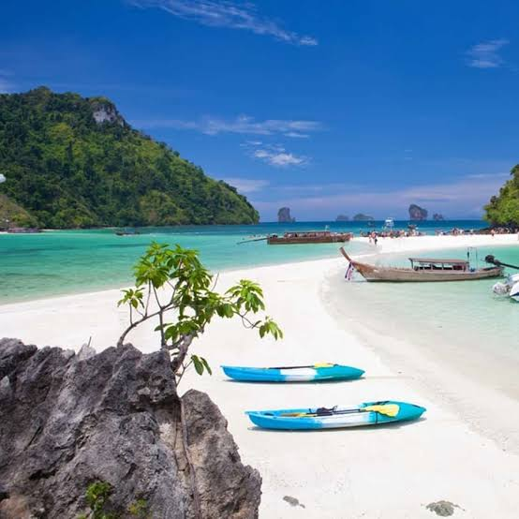
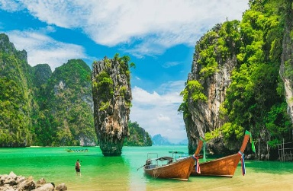
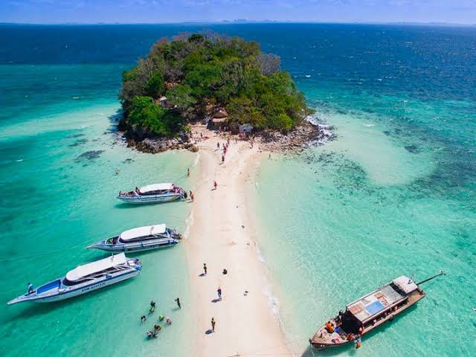
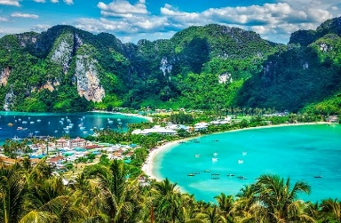
Krabi
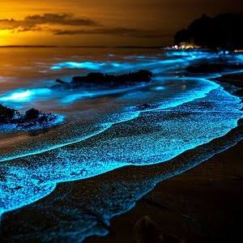
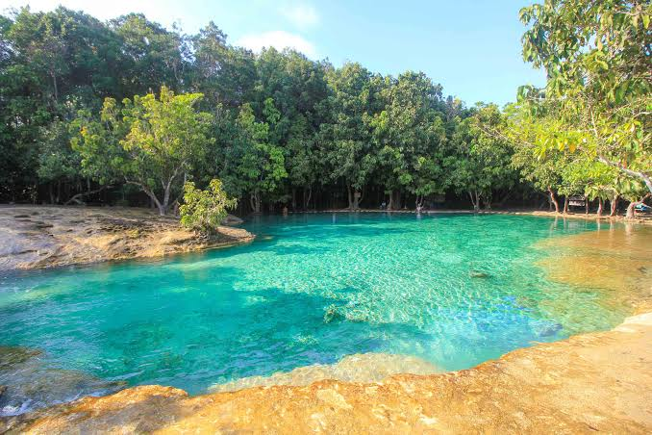
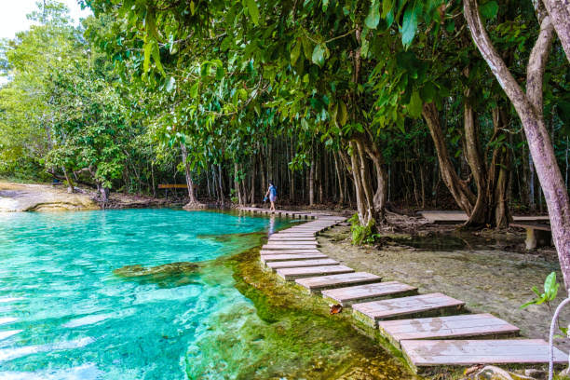
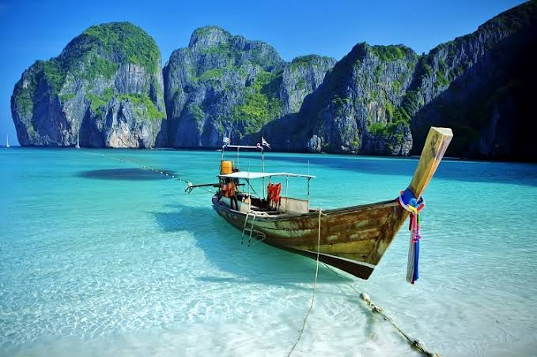

(1st Day) TataNagar to Phuket Airport

(2nd Day) Phuket Sightseeing
- Airport Pickup and Meetup
- City tours (with or without tiger/ elephant riding)
- Chalong Temple, Big Buddha viewpoint, Cashew nut Factory, Honey Farm
- Lunch at Restaurant
- Hotel Drop and Dinner at Local Restaurant

(3rd Day) Phi Phi Day Trip Sightseeing
- After Breakfast Hotel Pickup
- 07.30 Pick up from hotel to pier. Light breakfast at pier office.
- Visit Pileh Lagoon, Loh Samah, Viking Cave, Monkey Beach, Phi Phi Don and Khai Island
- lunch (buffet Indian food) at Phi Phi Don
- Hotel Drop and Dinner at Local Restaurant

(4th Day) James Bond Sightseeing
- Hotel Pick Up
- 07.40 Pickup from hotel to pier. Light breakfast at pier.
- Visit Mangroove forest, cave trekking, canoeing around Hong Island, James Bond Island, Khao Ping Khan, Panyee floating village.
- Lunch at restaurant on Panyee Island, last visit at Naka Island.
- Hotel Drop and Dinner at Local Restaurant

(5th Day) Krabi 7 Island Sightseeing
- After Breakfast Hotel Pickup
- 07.00 Pick up from hotel to pier
- 09.30 Ferry departures to Krabi
- 11.30 Arrive in Krabi and check in
- 7 Island trip and plankton swimming.
- Hotel Drop and Dinner at Local Restaurant

(6th Day) Krabi Island Sightseeing
- After Breakfast Hotel Pickup
- Visit Hong Island Day Trip or one day trip to the Emerald Pool, Hot Spring Waterfall (Thailand Onzen), and Tiger Cave Temple, and or with kayaking. Kayaking in Krabi is closer to nature and clear water in the forest.
- Hotel Drop and Dinner at Local Restaurant

(7th Day)
- Drop To Airport as Per Flight Schedule.

(8th Day) Return to TataNagar

Package Included:
- Meals as per Itinerary (Breakfast, Lunch & Dinner)
- National Park Fee
- Tata to Kolkata Airport (Up & Down)
- Comfortable Air-conditioned vehicle
- Accommodation during stay in Thailand – Phuket & Krabi
- English speaking Guide and Driver
- All entrance tickets in Thailand – Phuket & Krabi
- Mineral water during tour
- Parking tickets
- Return Airport Transfer
- Package cost *52,500* /Rs.

Package Excluded:
- Personal Expenses
- Flight Ticket
- TIPS
- Documentation video, photo, drone
- Water Activities
Cancellation Policy :
- Minimum Cancellation is Rs. 5,000/- per Head.
- 25% Between 30-20 Days Before Tour Departure
- 50% Between 20-10 Days Before Tour Departure
- 75% Between 10-05 Days Before Tour Departure
- 100% on the Same Day & No show.

